Total Marks: | 7.5
Obtained Marks:

Fundamentals of Programming
(Lab)

Final Project

Employee Management System

Names | Reg#
Ayad Ullah Bayg | 25108293
Ali Axhan Khan | 25108290
Saad Ali Khan | 25108329
Shahzain | 25108332
Jibran Abass | 25108310

Outline :
This project is a console-based Employee Management System developed using C++. It helps manage employee records such as personal details, salary, attendance, leaves, tasks, and performance. The system allows adding, deleting, searching, and updating employee information using a menu-driven interface. This project demonstrates the practical use of fundamental programming concepts such as arrays, functions, loops, and conditional statements.

Problem Statement :

Manual record keeping is time-consuming.
Difficult to manage employee data .
Risk of data loss and errors .
Objectives of the Project :
To understand basic C++ programming concepts .
To implement arrays for data storage .
To use functions for modular programming.
To design a menu-driven system .
To perform searching and updating of records .
Scope of the Project:
Add employee records .
View employee details .
Delete employee records .
Update attendance and leaves .
Assign tasks and performance .
Search employees by ID .

Tools & Technologies Used :
Programming Language: C++ .
Compiler: Dev-C++ .
Platform: Console-based application .
Main Features of the System :
Menu-driven interface.
Easy data entry.
Quick search using employee ID.
Simple and user-friendly design.
Efficient data management using arrays.
Concepts of C++ Used :
Input / Output Streams

Variables and Data Types

Arrays

Constants

Functions

Conditional Statements

Loops

Global Variables

String Handling

Limitations of the Project
Limited number of employees (20)
Data is not saved permanently
No file handling used
Console-based only
Future Enhancements:
Use file handling for data storage .
Convert into Object-Oriented Programming .
Add login system .
Increase employee limit .
Create GUI-based version .

SOURCE CODE :

#include <iostream>
#include <string>
using namespace std;

const int MAX_EMPLOYEES = 20;

int employeeIDs[MAX_EMPLOYEES];
string employeeNames[MAX_EMPLOYEES];
string employeeDepartments[MAX_EMPLOYEES];
double employeeSalaries[MAX_EMPLOYEES];
int employeeAttendance[MAX_EMPLOYEES]; // Number of days attended
int employeeLeaves[MAX_EMPLOYEES]; // Number of leave days taken
string employeeTasks[MAX_EMPLOYEES]; // Current task assignment
string employeePerformance[MAX_EMPLOYEES]; // Performance evaluations
int employeeCount = 0;

void addEmployee() {
if (employeeCount >= MAX_EMPLOYEES) {
cout << "Employee list is full!\n";
return;
}

cout << "Enter ID: ";
cin >> employeeIDs[employeeCount];
cin.ignore();
cout << "Enter Name: ";
getline(cin, employeeNames[employeeCount]);
cout << "Enter Department: ";
getline(cin, employeeDepartments[employeeCount]);
cout << "Enter Salary: ";
cin >> employeeSalaries[employeeCount];
cin.ignore();

employeeAttendance[employeeCount] = 0;
employeeLeaves[employeeCount] = 0;
employeeTasks[employeeCount] = "";
employeePerformance[employeeCount] = "";
employeeCount++;
cout << "Employee added successfully!\n";
}

void viewEmployees() {
if (employeeCount == 0) {
cout << "No employees to display!\n";
return;
}

for (int i = 0; i < employeeCount; i++) {
cout << "ID: " << employeeIDs[i] << "\n";
cout << "Name: " << employeeNames[i] << "\n";
cout << "Department: " << employeeDepartments[i] << "\n";
cout << "Salary: " << employeeSalaries[i] << "\n";
cout << "Attendance: " << employeeAttendance[i] << "\n";
cout << "Leaves: " << employeeLeaves[i] << "\n";
cout << "Task: " << employeeTasks[i] << "\n";
cout << "Performance: " << employeePerformance[i] << "\n";
cout << "-----------------------\n";
}
}

void deleteEmployee() {
if (employeeCount == 0) {
cout << "No employees to delete!\n";
return;
}

int id;
cout << "Enter the ID of the employee to delete: ";
cin >> id;

int index = -1;
for (int i = 0; i < employeeCount; i++) {
if (employeeIDs[i] == id) {
index = i;
break;
}
}

if (index == -1) {
cout << "Employee not found!\n";
return;
}

for (int i = index; i < employeeCount - 1; i++) {
employeeIDs[i] = employeeIDs[i + 1];
employeeNames[i] = employeeNames[i + 1];
employeeDepartments[i] = employeeDepartments[i + 1];
employeeSalaries[i] = employeeSalaries[i + 1];
employeeAttendance[i] = employeeAttendance[i + 1];
employeeLeaves[i] = employeeLeaves[i + 1];
employeeTasks[i] = employeeTasks[i + 1];
employeePerformance[i] = employeePerformance[i + 1];
}

employeeCount--;
cout << "Employee deleted successfully!\n";
}

void updateAttendance() {
int id, days;
cout << "Enter the ID of the employee to update attendance: ";
cin >> id;
cout << "Enter the number of days attended: ";
cin >> days;

for (int i = 0; i < employeeCount; i++) {
if (employeeIDs[i] == id) {
employeeAttendance[i] = days;
cout << "Attendance updated successfully!\n";
return;
}
}

cout << "Employee not found!\n";
}

void updateLeaves() {
int id, days;
cout << "Enter the ID of the employee to update leaves: ";
cin >> id;
cout << "Enter the number of leave days taken: ";
cin >> days;

for (int i = 0; i < employeeCount; i++) {
if (employeeIDs[i] == id) {
employeeLeaves[i] = days;
cout << "Leaves updated successfully!\n";
return;
}
}

cout << "Employee not found!\n";
}

void assignTask() {
int id;
string task;
cout << "Enter the ID of the employee to assign a task: ";
cin >> id;
cin.ignore();
cout << "Enter the task description: ";
getline(cin, task);

for (int i = 0; i < employeeCount; i++) {
if (employeeIDs[i] == id) {
employeeTasks[i] = task;
cout << "Task assigned successfully!\n";
return;
}
}

cout << "Employee not found!\n";
}

void updatePerformance() {
int id;
string performance;
cout << "Enter the ID of the employee to update performance: ";
cin >> id;
cin.ignore();
cout << "Enter the performance evaluation: ";
getline(cin, performance);

for (int i = 0; i < employeeCount; i++) {
if (employeeIDs[i] == id) {
employeePerformance[i] = performance;
cout << "Performance updated successfully!\n";
return;
}
}

cout << "Employee not found!\n";
}

void searchEmployee() {
int id;
cout << "Enter the ID of the employee to search: ";
cin >> id;

for (int i = 0; i < employeeCount; i++) {
if (employeeIDs[i] == id) {
cout << "Employee found:\n";
cout << "ID: " << employeeIDs[i] << "\n";
cout << "Name: " << employeeNames[i] << "\n";
cout << "Department: " << employeeDepartments[i] << "\n";
cout << "Salary: " << employeeSalaries[i] << "\n";
cout << "Attendance: " << employeeAttendance[i] << "\n";
cout << "Leaves: " << employeeLeaves[i] << "\n";
cout << "Task: " << employeeTasks[i] << "\n";
cout << "Performance: " << employeePerformance[i] << "\n";
return;
}
}

cout << "Employee not found!\n";
}

int main() {
int choice;
do {
cout << "\nEmployee Management System\n";
cout << "1. Add Employee\n";
cout << "2. View Employees\n";
cout << "3. Delete Employee\n";
cout << "4. Update Attendance\n";
cout << "5. Update Leaves\n";
cout << "6. Assign Task\n";
cout << "7. Update Performance\n";
cout << "8. Search Employee\n";
cout << "9. Exit\n";
cout << "Enter your choice: ";
cin >> choice;

switch (choice) {
case 1:
addEmployee();
break;
case 2:
viewEmployees();
break;
case 3:
deleteEmployee();
break;
case 4:
updateAttendance();
break;
case 5:
updateLeaves();
break;
case 6:
assignTask();
break;
case 7:
updatePerformance();
break;
case 8:
searchEmployee();
break;
case 9:
cout << "Exiting...\n";
break;
default:
cout << "Invalid choice! Please try again.\n";
}
} while (choice != 9);

return 0;
}

Output Of Source Code :
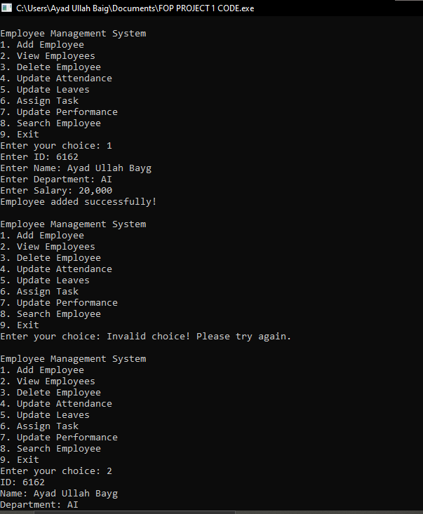

Conclusion :

This project provided us with practical understanding of the fundamental concepts of programming using C++. Through the development of the Employee Management System, we successfully applied arrays, functions, loops, and conditional statements in a real-world scenario. The menu-driven design made the system simple and user friendly. This project also improved our problem-solving skills and teamwork experience. Overall, the project fulfilled its objectives and strengthened our programming foundation.

